**Robotic Tattoo Removal**

13591% of 128155 of623[Peter Rhodes](http://www.codewars.com/users/Peter%20Rhodes)

Java

* [TRAIN AGAIN](http://www.codewars.com/kata/robotic-tattoo-removal/train/java)
* [NEXT KATA](http://www.codewars.com/trainer/java)

Details

[Solutions](http://www.codewars.com/kata/robotic-tattoo-removal/solutions/java)

[Discourse (7)](http://www.codewars.com/kata/robotic-tattoo-removal/discuss/java)

* Add to Collection
* |
* Share this kata:

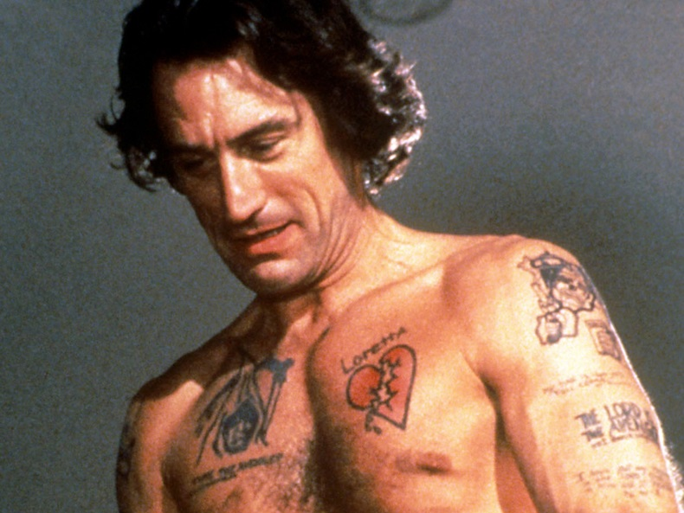

Sometimes people get tattoos, sometimes they wish they hadn't, sometimes the tattoos must go. Lets create a robot that can remove tattoos.

Your robot function accepts one array argument called skinScan. I have supplied an example array below.

[

[' ',' ',' ',' ',' ',' ',' ',' ',' ',' ',' '],

[' ',' ',' ',' ',' ',' ',' ',' ',' ',' ',' '],

[' ',' ','X','X',' ',' ',' ','X','X',' ',' '],

[' ','X',' ',' ','X',' ','X',' ',' ','X',' '],

[' ','X',' ',' ',' ','X',' ',' ',' ','X',' '],

[' ','X',' ',' ',' ','X',' ',' ',' ','X',' '],

[' ','X',' ',' ',' ',' ',' ',' ',' ','X',' '],

[' ','X',' ',' ',' ',' ',' ',' ',' ','X',' '],

[' ','X',' ',' ',' ',' ',' ',' ',' ','X',' '],

[' ',' ','X',' ',' ',' ',' ',' ','X',' ',' '],

[' ',' ',' ','X',' ',' ',' ','X',' ',' ',' '],

[' ',' ',' ',' ','X',' ','X',' ',' ',' ',' '],

[' ',' ',' ',' ',' ','X',' ',' ',' ',' ',' '],

[' ',' ',' ',' ',' ','X',' ',' ',' ',' ',' '],

[' ',' ',' ',' ',' ',' ',' ',' ',' ',' ',' '],

[' ',' ',' ',' ',' ',' ',' ',' ',' ',' ',' ']

]

Your task is to create a function for the robot function that will zap away the Xs and replace them with *s. Any array values that are not Xs must be left alone. Below is what skinScan should look like after the tattoo has been removed.

[

[' ',' ',' ',' ',' ',' ',' ',' ',' ',' ',' '],

[' ',' ',' ',' ',' ',' ',' ',' ',' ',' ',' '],

[' ',' ','*','*',' ',' ',' ','*','*',' ',' '],

[' ','*',' ',' ','*',' ','*',' ',' ','*',' '],

[' ','*',' ',' ',' ','*',' ',' ',' ','*',' '],

[' ','*',' ',' ',' ','*',' ',' ',' ','*',' '],

[' ','*',' ',' ',' ',' ',' ',' ',' ','*',' '],

[' ','*',' ',' ',' ',' ',' ',' ',' ','*',' '],

[' ','*',' ',' ',' ',' ',' ',' ',' ','*',' '],

[' ',' ','*',' ',' ',' ',' ',' ','*',' ',' '],

[' ',' ',' ','*',' ',' ',' ','*',' ',' ',' '],

[' ',' ',' ',' ','*',' ','*',' ',' ',' ',' '],

[' ',' ',' ',' ',' ','*',' ',' ',' ',' ',' '],

[' ',' ',' ',' ',' ','*',' ',' ',' ',' ',' '],

[' ',' ',' ',' ',' ',' ',' ',' ',' ',' ',' '],

[' ',' ',' ',' ',' ',' ',' ',' ',' ',' ',' ']

]

FUNDAMENTALS

ARRAYS

GRAPHS

DATA STRUCTURES

<http://www.codewars.com/kata/robotic-tattoo-removal/java>

public static String[][] robot(String[][] skinScan) {

String[][] res = new String[skinScan.length][];

for(int i =0; i<skinScan.length; i++) {

res[i] = new String[skinScan[i].length];

for(int j =0; j<skinScan[i].length; j++) {

if(skinScan[i][j].equals("X")){

res[i][j] = "*";

}else{

res[i][j] = skinScan[i][j];

}

}

}

return res;

};

-------otra solución------------

**public static String[][] robot(String[][] skinScan) {**

**for (String[] row : skinScan) {**

**for (int i = 0; i < row.length; i ++) {**

**if (row[i].equals("X")) {**

**row[i] = "*";**

**}**

**}**

**}**

**return skinScan;**

**};**